procedures following lift of boil water order/advisory

**Applicable to**: All water circuits, spray stations, beverage dispensers, brewers, ice machines, water softeners, water holding tanks and filtration systems in Restaurants affected by a Boil Water Order/Advisory.

**Maintenance Performed by:** Qualified service professional or experienced Team Member.

**CAUTION**

• All procedures must be performed **after** the Boil Water Order/Advisory has been lifted by the local or state Health Department.

• Procedures listed below must be **performed in the order shown**. Failure to comply may recontaminate potable water supplies.

• Restaurants with water softeners, Tea Nano water systems, Nano water systems, or reverse osmosis water systems will require a certified water filtration service provider to sanitize and **restart** this equipment. Contact Strategic Equipment at 866-324-4253 EXT. 5 for a referral.

• Ensure you have new filters and O-rings on hand **first** before performing procedures.

**Everpure Reverse Osmosis filtration system (Type III RO)**

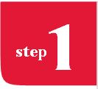 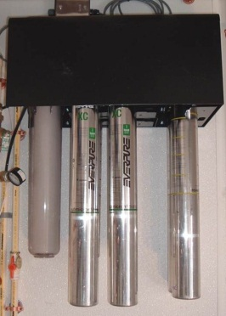 C:\Users\Craig Minor\Desktop\NEW RO TRAINING 02_23_12\RO_PRESENTATION_PIX\IN ORDER\RO-16.jpg 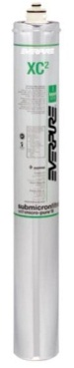 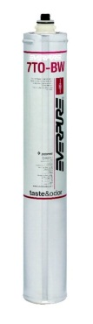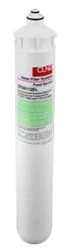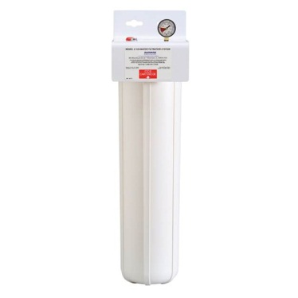

Ensure You Have New Filters, O-Rings and Membranes

**Service Agent Task**

Order replacement membranes, filters, cartridges, and air filter directly from B&R Industries (Michael Kannapel) at 480-898-0008. Give them the restaurant’s Unit number and tell them this is an Everpure Reverse Osmosis filtration system.**. Do not substitute off-brand filters.** Filter bowl O-rings must be included in the order.

 Sanitization of Softener and Water Holding Tank

**Service Agent Task**

• Unplug the RO system from the wall outlet

• Add 1 cup of KAY-5 sanitizer to water softener brine tank. Add sanitizer directly to standing water through the plastic stand pipe. Do not pour sanitizer directly onto the salt. For small point of use softeners add 2 tablespoons of sanitizer through the brine tank stand pipe. Force controller into the regeneration cycle. After the regeneration cycle, calibrate the controller and set clock. Note: If power has been interrupted, the clock on the controller will not be correct, and may result in regeneration during business hours.

• Calibrate water softener to dose salt at the rate of 8 lbs. per cu. ft. of resin. Contact the CFA Facilities & Equipment line at EXT. 58998 for further calibration specifications.

• Add 2 packets of KAY-5 sanitizer (Green Pack) to the green Reverse Osmosis water holding tank. **Fill** tank to the brim with city water. Allow the tank to sit undisturbed for 1 hour. Power-flush the tank using the delivery pump.

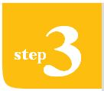 Remove Old Filters & Flush Lines

**Team Member Task**

• Discard all ice from ice maker bins and beverage tower ice bins.

• Plug all carbonator pumps in.

• Open all water circuits (hot and cold) at hand sinks, 3-compartment sinks, veggie prep sink, mop sink, filtered water faucet and spray stations. Run continuously for 30 minutes. Open each beverage dispensing valve and water dispenser at each beverage tower and run each for 2 minutes.

• Run coffee and tea brewers for 2 complete brew cycles. Discard water.

• Clean and sanitize Hoshizaki ice machines by following the instructions on the inside cover of the ice machine. Use only Hoshizaki approved sanitizer. Run cuber ice machine through 3 ice making cycles. Run cubelet ice machine for 20 minutes of ice production. Discard all ice. Contact Hoshizaki Tech Support at 800-233-1940.

• Clean and sanitize underside of ice machine, ice bin and all ice bins at beverage towers.

**Service Agent Task**

• Ensure that filter systems are bypassed or the incoming water is shut off before attempting to remove any cartridge.

• Remove and discard all 7 filter and membrane cartridges from the Reverse Osmosis Processor. Remove the post filter cartridge (may be a pre filter cartridge as well).

• Sanitize filter heads and cartridge bowls with KAY-5 sanitizer (Green Pack).

• Remove and discard the air filter on the Reverse Osmosis water holding tank.

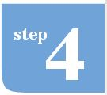Install New Filters & Start System

**Service Agent Task**

• Replace the 7 filter cartridges and membranes in the Reverse Osmosis processor. Replace post filter cartridge (and pre-filter cartridge, if applicable).

• Flush carbon filters to drain for 5 minutes.

• Flush the membranes to drain for 60 minutes.

• Install the new air filter on the Reverse Osmosis water holding tank.

• Plug the Reverse Osmosis processor back into the outlet and calibrate to 33% recovery and 150 ppm TDS ingredient water. Contact the CFA Facilities & Equipment line at EXT. 58998 if you have any difficulty getting the Reverse Osmosis system to calibration specification.

• Allow Reverse Osmosis system to fill holding tank until at least half full before leaving the restaurant.

Costs & Billing

• The cost of filters, cartridges, membranes, salt, air filter, sanitizer plus labor for installation, sanitation and calibration of equipment will be refunded to the Restaurant via TBR to the Equipment Group at Chick-fil-A headquarters. Indicate “**Boil Water Order/Advisory- Type III RO**” on the notes section of the TBR.

In addition, be sure to perform the following:

• Clean and sanitize interior of ice machines, bins, ice buckets and scoops

• Discard the entire first batch of ice before serving customers

• Clean and sanitize all sinks and ice bins in FOH before use

• Clean and sanitize all fixtures, sinks (3-compartment, handwashing, produce and restrooms) and other equipment connected to water lines

• Confirm with local Health Department that any other procedures that are required are completed